Ballarat is Back - So Is The Ballarat Silver Racket!

The Ballarat Real Tennis Club is delighted to announce the club’s open Silver Racket tournament is back in the calendar, after decades. The BSR will be held over the weekend of 16/17 January 2027 at the refurbished and re-energised BRTC, 613 Main Road, Golden Point, 3350, Victoria. After playing the 2027 Australian Open in Sydney (4-14 Jan), you are invited to play for the Ballarat Silver Racket. We look forward to welcoming you back.
Entry size and timing:
- The event is open to the top 8 players entering, firstly by world ranking and then by handicap at the time of the draw closing. This will be on the same day as the 2027 AO, 25 November 2026.
- Acceptance of entry and public streamed draw will follow on 28 November, to allow travel planning
- Seedings: the World Rankings will be used to seed those entrants who have a ranking within the top 15 of the World Singles Rankings as at the close of entries on 25.11.26. Thereafter, seedings will be based on the singles handicaps displayed on the RTO Website (www.realtennisonline.com) at the closing date for entries.

Event format:

- The tournament will be played under the ARTA Rules of Real Tennis in Australia (at www.realtennisaustralia.com.au).
- It will be a knock-out event, played over the best of 3 x six-game set matches.
- Qualifying on Friday 15 January, if entry numbers exceed places in the draw, and practice courts. Email Maggie Henderson-Tew at maggie.ht@btinternet.com to enter the draw by 25.11.26, or earlier to ask any questions arising.
- Streaming time and details will be advised nearer the time to all competitors.
- Players will be expected to mark one match in return for their appearance fee.
- Play will conclude on Sunday 17 January in time for evening flights from Melbourne.

Prize Fund:

- There will be a minimum prize pool of AUD $20,000.
- Each competitor will receive AUD $1,000 appearance fee and the prize fund will be distributed in accordance with the IRTPA formula.
- A case of the finest Australian sparkling wine will be given to the amateur player who progresses furthest in the competition, or wins it, or, in the event of there being no amateur participants, will be shared between the BSR player goodie bags.

Extras:

- Billets should be requested by end November following your entry being confirmed
- Players will be provided with lunch each day, booked in advance.
- Travel from Melbourne to Ballarat and back will be arranged on request.
- There will be no events at which players’ presence is required but entrants will be most welcome at an informal BBQ and drinks party at the club, to enjoy the famous hospitality of the Ballarat Real Tennis Club.

Historical Note

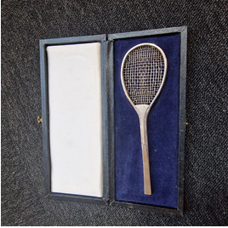

The fine Silver Racket trophy was generous donated by Mike Garnett in 1985, when it was won by Chris Ronaldson. Other winners were Chris Bray, Brad Dale, Lachie Deuchar, Frank Fillipelli, Mike Gooding, Graham Hyland, Jonners, Brett McFarlane and Julian Snow.
The Ballarat Silver Racket has not been held as an annual competition since 1999. We are delighted that Mike Garnett will be with us to present it to the winner on 17 January 2027.
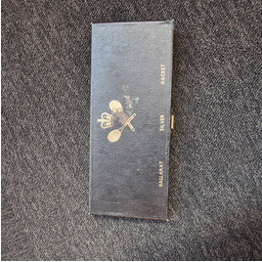
Summary –
- The Ballarat Silver Racket at the Ballarat Real Tennis Club.
- 16 and 17 January 2027, with practice on Friday 15 January.
- Entries close on 25 November.
- Prize Fund not less than AUD $20,000.
- Email Maggie Henderson-Tew at maggie.ht@btinternet.com to enter the draw and ask any questions arising.

